Table of Contents
1. Introduction 1
2. Objective and Requirements 1
3. Tools Used 1
4. Wireframe 1
5. Implementation 1
6. Source Code 1
7. Output Screenshots 1
8. Conclusion 1

Introduction
This document describes the design, implementation and testing of a basic interactive graphical user interface (GUI) built with Java Swing. Java Swing is a lightweight GUI toolkit in the javax.swing package that lets programmers create windows, containers and controls. Event driven programming means the program does not run in a fixed sequence; instead, it waits for events such as button clicks and responds to each one through an event handler. This assignment applies those ideas in a small application made up of a JFrame, a JPanel and a JLabel, with object-oriented concepts (inheritance and constructors) and an ImageIcon application icon.

2. Objective and Requirements
The objective is to create a basic GUI application that uses a JFrame, JLabel and JPanel, and that demonstrates inheritance and constructors. The requirements from the assignment brief were met as follows:
Requirement | How it is implemented
Class called SwingAssignment | public class SwingAssignment
JFrame variable named frame | private JFrame frame; created with new JFrame("Java Swing Assignment")
JPanel variable named panel | private JPanel panel; instantiated as new GradientPanel(...) (a subclass of JPanel)
JLabel variable named label | private JLabel label; instantiated with the required welcome text
Add label to panel, panel to frame | panel.add(label, c); frame.add(panel);
Title and 800x800 size | frame.setSize(800, 800) and the title in the JFrame constructor
Closes on close button | frame.setDefaultCloseOperation(JFrame.EXIT_ON_CLOSE)
Own icon with ImageIcon | icon.png loaded as an ImageIcon: window icon and a scaled logo above the text
Inheritance | GradientPanel extends JPanel and overrides paintComponent()
Constructor | GradientPanel(Color, Color) and SwingAssignment()
Addition: change label text | "Apply Text" (typed text) and "Random Quote" buttons call label.setText(...)
Addition: change panel background | "Next Theme" calls setColors(...) which repaints a new gradient

3. Tools Used
- Figma – to design the wireframe.
- IntelliJ IDEA / VS Code with JDK 17 or later – to write and run the Java code.
- Git and GitHub – version control and submission.

4. Wireframe
The wireframe below shows the planned layout: an 800 x 800 pixel JFrame with the title "Java Swing Assignment" and the application icon, containing one gradient JPanel that holds a logo, the welcome JLabel, a JTextField and three buttons for the interactive additions.
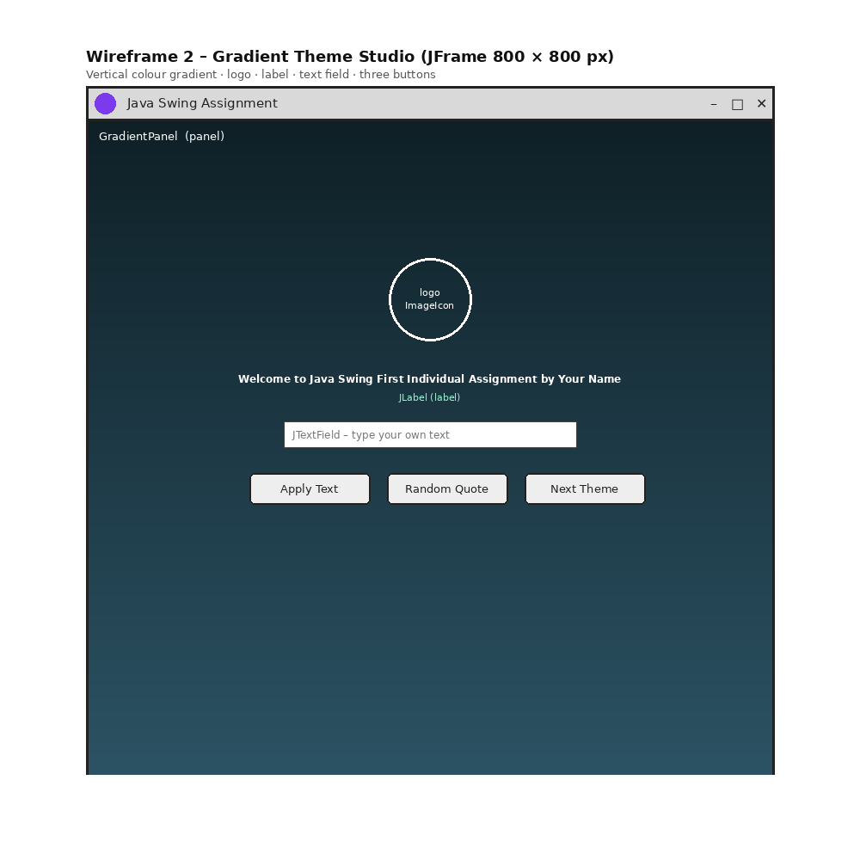
Figure 1: Wireframe of the application (replace with your Figma export if required)

5. Implementation
Inheritance. GradientPanel extends JPanel. It inherits all panel behaviour and overrides paintComponent() to draw a vertical gradient with GradientPaint. The variable panel is declared as a JPanel but holds a GradientPanel object (polymorphism).
Constructors. The GradientPanel constructor calls super(new GridBagLayout()) and stores the two gradient colours. The SwingAssignment constructor creates the frame, panel, logo, label, text field and buttons and joins them together.
ImageIcon. icon.png is loaded as an ImageIcon. It is used as the window icon with setIconImage() and, scaled to 96 x 96 pixels with getScaledInstance(), as a logo above the welcome message.
Event handling. ActionListeners (lambda expressions) respond to the three buttons and to the Enter key in the text field. "Apply Text" copies what the user typed into the label, "Random Quote" picks a quote with java.util.Random, and "Next Theme" moves to the next of five gradient themes and shows the theme name in the window title.
Design choices. All themes are dark so the white label text is always readable. The GUI is started with SwingUtilities.invokeLater() so it runs on the Event Dispatch Thread.

6. Source Code
File: SwingAssignment.java (icon.png must be in the same folder from which the program is run).
import javax.swing.ImageIcon;
import javax.swing.JButton;
import javax.swing.JFrame;
import javax.swing.JLabel;
import javax.swing.JPanel;
import javax.swing.JTextField;
import javax.swing.SwingUtilities;
import javax.swing.UIManager;
import java.awt.Color;
import java.awt.Dimension;
import java.awt.FlowLayout;
import java.awt.Font;
import java.awt.GradientPaint;
import java.awt.Graphics;
import java.awt.Graphics2D;
import java.awt.GridBagConstraints;
import java.awt.GridBagLayout;
import java.awt.Image;
import java.awt.Insets;
import java.io.File;
import java.util.Random;

/**
* PROG209 - Event Driven Programming
* Assignment 1: Basic Interactive GUI (Style 2 - "Gradient Theme Studio")
*
* Inheritance : GradientPanel extends JPanel (custom painted background)
* Constructor : GradientPanel(Color, Color) and SwingAssignment()
* ImageIcon : window icon + logo shown above the welcome message
* Interaction : type your own text, random quote, switch colour theme
*/
public class SwingAssignment {

// TODO: replace with your own full name
private static final String STUDENT_NAME = "Your Name";

// Required variables (names fixed by the brief)
private JFrame frame;
private JPanel panel;
private JLabel label;

// Extra components
private JTextField input;

// Theme data: {top colour, bottom colour}
private static final String[] THEME_NAMES = {"Ocean", "Midnight", "Forest", "Royal", "Plum"};
private static final Color[][] THEMES = {
{new Color(0x0F2027), new Color(0x2C5364)},
{new Color(0x141E30), new Color(0x35577D)},
{new Color(0x134E5E), new Color(0x2E8B57)},
{new Color(0x1E3C72), new Color(0x2A5298)},
{new Color(0x41295A), new Color(0x8E4585)}
};
private static final String[] QUOTES = {
"Code is like humour. When you have to explain it, it is bad.",
"First, solve the problem. Then, write the code.",
"Events drive the interface - the user is in control.",
"Practice makes a programmer."
};
private int themeIndex = 0;
private final Random random = new Random();

/* ---------- INHERITANCE: GradientPanel IS-A JPanel ---------- */
static class GradientPanel extends JPanel {
private Color top;
private Color bottom;

// Constructor: stores the two gradient colours
GradientPanel(Color top, Color bottom) {
super(new GridBagLayout());
this.top = top;
this.bottom = bottom;
}

// Changes the background and repaints
void setColors(Color top, Color bottom) {
this.top = top;
this.bottom = bottom;
repaint();
}

// Overrides JPanel to paint a vertical gradient
@Override
protected void paintComponent(Graphics g) {
super.paintComponent(g);
Graphics2D g2 = (Graphics2D) g.create();
g2.setPaint(new GradientPaint(0, 0, top, 0, getHeight(), bottom));
g2.fillRect(0, 0, getWidth(), getHeight());
g2.dispose();
}
}

/* ---------- CONSTRUCTOR: builds the GUI ---------- */
public SwingAssignment() {
// JFrame (frame)
frame = new JFrame("Java Swing Assignment");
frame.setSize(800, 800);
frame.setLocationRelativeTo(null);
frame.setDefaultCloseOperation(JFrame.EXIT_ON_CLOSE);

// ImageIcon: own application icon
ImageIcon icon = new ImageIcon("icon.png");
if (icon.getIconWidth() > 0) {
frame.setIconImage(icon.getImage());
}

// JPanel (panel) - an instance of the subclass GradientPanel
panel = new GradientPanel(THEMES[0][0], THEMES[0][1]);

// Logo using ImageIcon (scaled)
JLabel logo = new JLabel();
if (icon.getIconWidth() > 0) {
logo.setIcon(new ImageIcon(icon.getImage().getScaledInstance(96, 96, Image.SCALE_SMOOTH)));
}

// JLabel (label)
label = new JLabel("Welcome to Java Swing First Individual Assignment by " + STUDENT_NAME);
label.setFont(new Font("SansSerif", Font.BOLD, 18));
label.setForeground(Color.WHITE);

// Controls
input = new JTextField(28);
input.setFont(new Font("SansSerif", Font.PLAIN, 14));
JButton applyBtn = makeButton("Apply Text");
JButton quoteBtn = makeButton("Random Quote");
JButton themeBtn = makeButton("Next Theme");

applyBtn.addActionListener(e -> applyText());
input.addActionListener(e -> applyText()); // Enter key also works
quoteBtn.addActionListener(e -> label.setText(QUOTES[random.nextInt(QUOTES.length)]));
themeBtn.addActionListener(e -> nextTheme());

JPanel buttons = new JPanel(new FlowLayout(FlowLayout.CENTER, 12, 0));
buttons.setOpaque(false);
buttons.add(applyBtn);
buttons.add(quoteBtn);
buttons.add(themeBtn);

// Layout inside panel
GridBagConstraints c = new GridBagConstraints();
c.gridx = 0;
c.insets = new Insets(10, 10, 10, 10);
c.gridy = 0; panel.add(logo, c);
c.gridy = 1; panel.add(label, c); // label added to panel
c.gridy = 2; panel.add(input, c);
c.gridy = 3; panel.add(buttons, c);

frame.add(panel); // panel added to frame
frame.setVisible(true);
}

private JButton makeButton(String text) {
JButton b = new JButton(text);
b.setFocusPainted(false);
b.setPreferredSize(new Dimension(140, 36));
return b;
}

// Change the text of the JLabel using what the user typed
private void applyText() {
String text = input.getText().trim();
if (!text.isEmpty()) {
label.setText(text);
input.setText("");
}
}

// Change the background of the JPanel
private void nextTheme() {
themeIndex = (themeIndex + 1) % THEMES.length;
((GradientPanel) panel).setColors(THEMES[themeIndex][0], THEMES[themeIndex][1]);
frame.setTitle("Java Swing Assignment - " + THEME_NAMES[themeIndex] + " theme");
}

public static void main(String[] args) {
try {
UIManager.setLookAndFeel(UIManager.getSystemLookAndFeelClassName());
} catch (Exception ignored) { }
SwingUtilities.invokeLater(SwingAssignment::new);
}
}

7. Output Screenshots
Run the program and insert clear screenshots below.
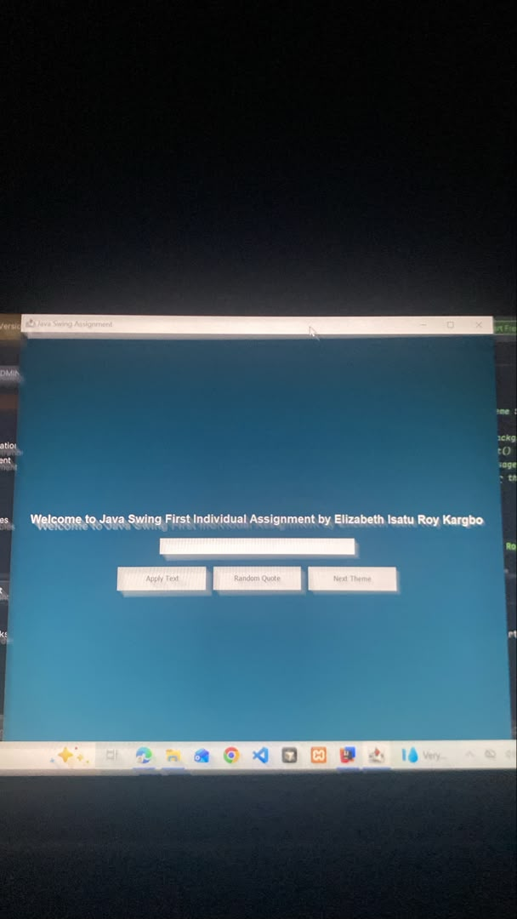
Figure 2: Application on start-up
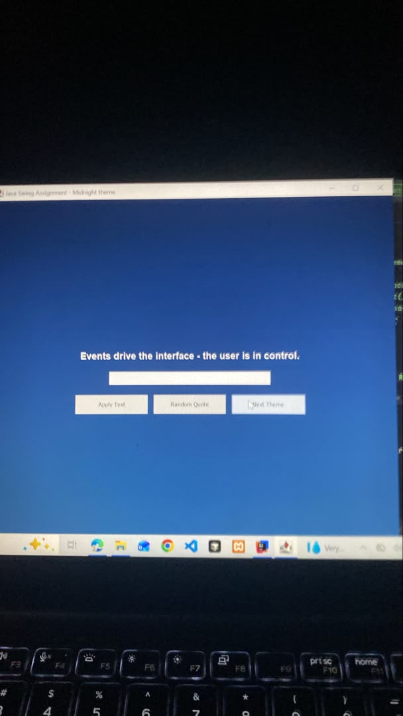
Figure 3: Label text changed by the user
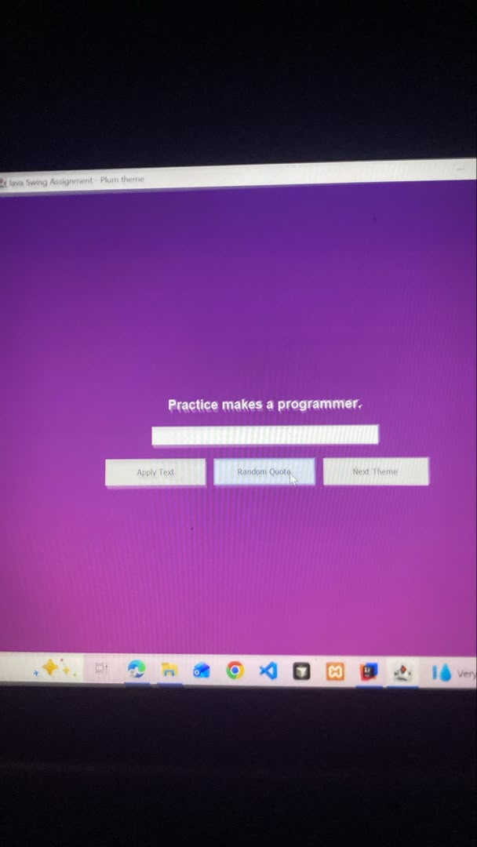
Figure 4: Gradient theme changed

Conclusion
The application meets all requirements of the assignment brief. It shows how a JFrame, JPanel and JLabel work together, how inheritance and constructors organise GUI code, how an ImageIcon provides a custom application icon, and how event listeners make the interface interactive. Possible future improvements include a JColorChooser so users can create their own gradient, saving the chosen theme to a file, and a menu bar.

